Coin Flip Tutorial- Short Handout
Getting Started  Open App Inventor with the Coin Flip Media Only template. This will open a project that contains the images you will need in this lesson. Use the Projects/Save As option to rename your project to CoinFlip. | 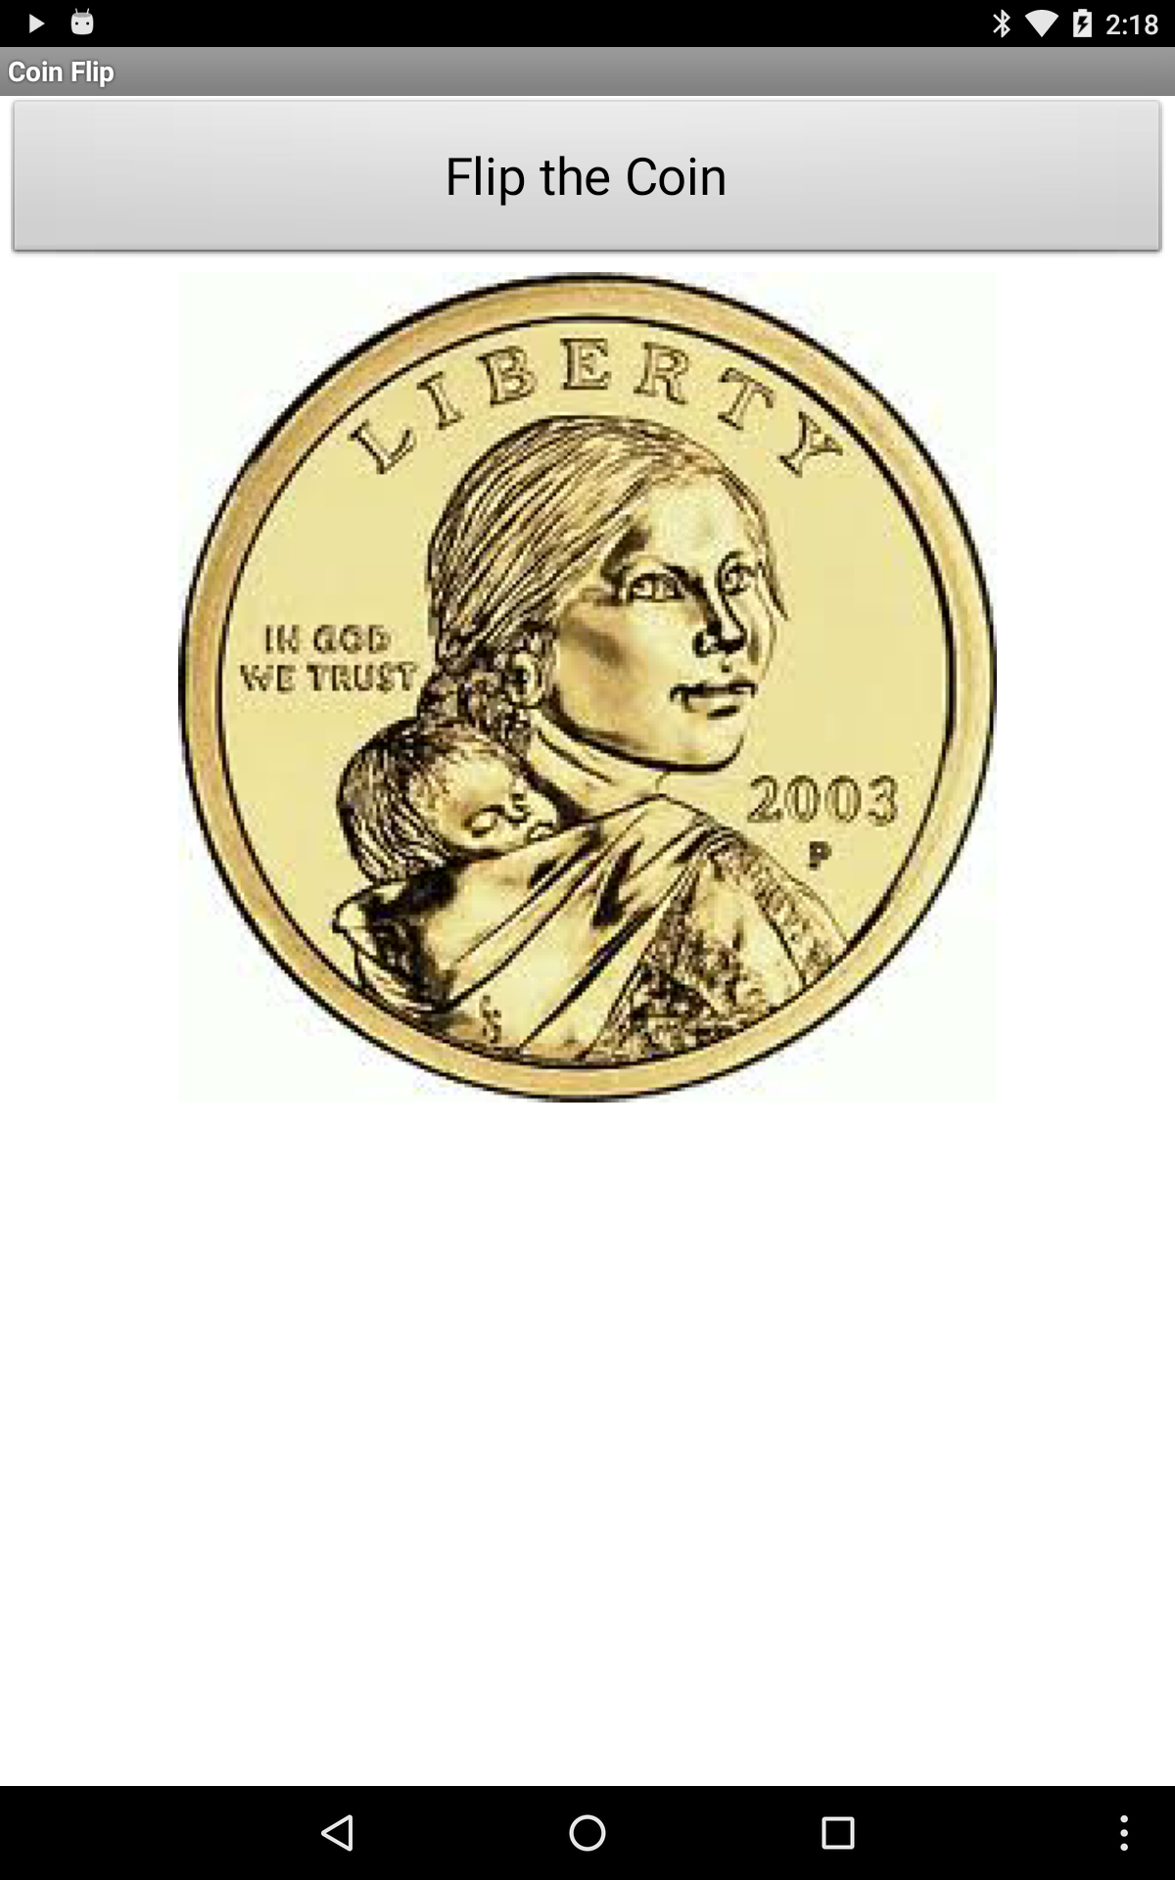  Image  Button

Designing the User Interface (UI)
UI Component | Name | Properties
Screen | Screen1 | Change:  Title = Coin Flip  AlignHorizontal = Center
Button | Button1 | Change:  Text = Flip the Coin  Width= Fill Parent
Image | Image1 | - Change:  - Picture = heads.jpg

Coding the App
Variable |  | Value
coin |  | 1

Event Handler |  | Algorithm
Button1.click |  | Set coin to random integer from 1 to 2  If coin = 1, then set Image1.picture to the text “heads.jpg”  else set Image1.picture to the text “tails.jpg”

Testing the App
Inputs |  | Expected Outputs | Actual Outputs
Click “Flip the Coin” |  | Coin image changes to heads or tails image randomly. | ?

Coin Flip Part 2: Repeating the Coin Flip N Times

Designing the User Interface (UI)
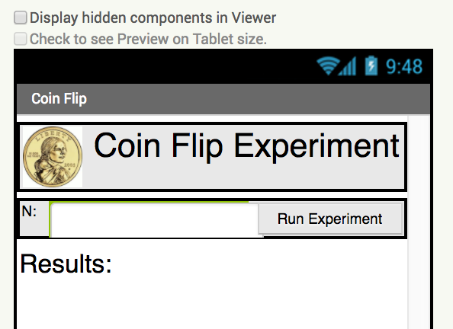
Image (smaller)
Label
Button
Label
TextBox
Label
UI Component | Name | Properties
Horizontal Arrangement | HorizontalArrangement1 | Place at the top of the screen.  Change:  Width = fill parent
Image | Image1 | Place in the left side of HorizontalArrangement1 Change:  Width = 50  Height = 50
Label | LabelTitle | Place in the right side of HorizontalArrangement1 .  Change:  FontSize = 30  Text = Coin Flip Experiment
Horizontal Arrangement | HorizontalArrangement2 | Place under HorizontalArrangement1.  Change:  Width = fill parent
Label | LabelN | Place in the left side of HorizontalArrangement2.  Change:  Text = N:
Text Box | TextBoxN | Place in the middle of HorizontalArrangement2.  Change:  NumbersOnly = checked
Button | Button1 | Move to the right side of HorizontalArrangement2. Change:  Rename = ButtonGo  Text = Run the Experiment
Label | LabelResults | Place below HorizontalArrangement2.  Change:  Width = fill parent  FontSize = 24

Coding the App
Variables | Values
N | 0
nHeads | 0
coin | 1

Event handlers |  | Algorithms
ButtonGo.Click |  | Set global N to TextBoxN.Text  Set global nHeads to 0  For each number 1 to get Global N  Set coin to random integer from 1 to 2  If coin = 1, then increment nHeads (set nHeads to get nHeads + 1)  Set LabelResults.text join 4 blocks: Text “Heads:”, nHeads, Text “ Tails:”, N - nHeads.

Testing the App
Inputs |  | Expected Outputs | Actual Outputs
Type in 100 for N and click Run the Experiment. |  | Results returned should sum up to 100.  The results should also be fairly close to 50% heads and 50% tails. | ?
Type in 1000 for N and click Run the Experiment. |  | Results returned should sum up to 1000. The results should be closer to 500 heads and 500 tails. | ?

